# Low Level Design (LLD)

Restaurant Rating Prediction

Pallav Chavda

# Contents

Abstract

1. Introduction 1

Why is low-level Design documentation? . 1 Scope 2

Constraints 2

Out of scope 2

1. Technical Specification 2

Dataset 2

Dataset overview 3

Input schema 3

Predicting 4

Logging 4

Database 4

Deployment 4

1. Technology Stack 5
2. Proposed Solution 5
3. Model Training/Validation Workflow 6
4. User I/O workflow 7
5. Test cases 8

Abstract

Restaurants nowadays prefer taking online orders. It not only helps in getting effective customer feedback but also useful for managing orders easily. We are moving towards an automated and digital world. Having a significant online presence is necessary for any restaurant to be successful and prosperous. Getting customer feedback and analyzing them in an effective manner makes the difference. This study analyses the restaurant reviews and presents useful information that the ratings do not consider or overlook. Combined research is done using datasets of different restaurant features. Machine learning algorithms like Random Forest and Extra Tree regression is used for first classifying the reviews in proper aspects then performing EDA on them. Summarization is done using effective visualization techniques. Future work is also discussed so that an efficient analysis system can be developed utilizing the potential of reviews.

## Introduction

Why this Low-Level Design Documentation?

The purpose of this documentation is detailed description of restaurant rating prediction system which will explain the purpose and the feature of the system, the interfaces of the system, what the system will do, the constraints under which it must operate and how the system will perform under different parameters. This document is intended for both the stack holders and developers of the system and will be proposed for the higher management for its approval.

The main objective of the project is taking restaurant's location and services provided by them into consideration this model will predict the rating of the restaurant. The restaurants make sure that all the data is available at that time in order to get the optimum utilization of this system and earn maximum profits.

This project can be delivered in three phases

Phase 1: Building Machine learning model depending on the requirements.

Phase 2: Integration of UI and database to all the functionalities.

## Scope

This software system will be a web application, this system will be designed to predicts the rating of the restaurant based on the user's input in which there are several categories to fill in like the online order, table booking, votes, location, restaurant type, dish liked, cuisines, cost of two person and type of restaurant. Based on these features model will predict the rating of a restaurant. We make sure that all the given features should be available at that time in order to get the optimum utilization and earn maximum profits by the company.

## Constraints

It is a project based of Bangalore zomato restaurant data.

## Out of scope

System will not be Perform good if restaurant is not in Bangalore region.

1. Technical Specifications

## Dataset

|  |  |  |
| --- | --- | --- |
| Data | Finalize d | Sourc e |
| Zomato Restaurant | Yes | [https://www.kaggle.com/himansh](https://www.kaggle.com/himanshupoddar/zomato-bangalore-restaurants) [upoddar/zomato-bangalore-](https://www.kaggle.com/himanshupoddar/zomato-bangalore-restaurants)  [restaurants](https://www.kaggle.com/himanshupoddar/zomato-bangalore-restaurants) |

## Dataset Overview

51717 – rows

17 – columns

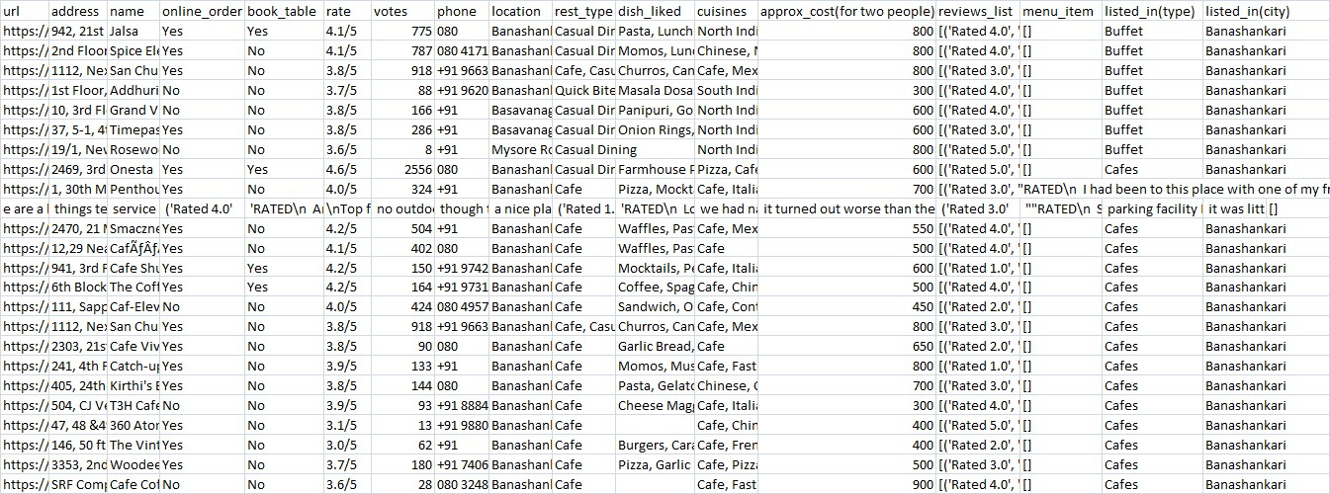

## Input Schema

|  |  |
| --- | --- |
| **url** | **object** |
| **address** | object |
| **name** | object |
| **online_order** | object |
| **book_table** | object |
| **rate** | object |
| **votes** | int64 |
| **phone** | object |
| **location** | object |
| **rest_type** | object |
| **dish_liked** | object |
| **cuisines** | object |
| **approx_cost(for two people)** | object |
| **reviews_list** | object |
| **menu_item** | object |
| **listed_in(type)** | object |
| **listed_in(city)** | object |

## Predicting

* + The system displays the restaurant rating according to the users input.
  + The system presents the set of inputs required from the user.
  + The user gives required information.
  + The system should be able to predict the rating of restaurant for the information provided by the user.

## Database

The system stores each and every data given by the user or received on request to the database. We have used MongoDB.

## Technology stack

|  |  |
| --- | --- |
| Frond End | HTML/CSS |
| Backend | Python Flask |
| Database | MongoDB |
|  |  |

## Proposed Solution

The restaurant industry is one of the prevailing competitive sectors. People enjoy cherishing communal dining for centuries, hence the demand for restaurants increasing day by day. Bangalore is a heaven for foodies with a range of cuisines from different parts of the world. In this paper, the data set for restaurants for a specific location is identified and the Data Visualization tools are applied to understand the trends and patterns of the food culture. This software proposes a model to understand the factors affecting the rating of restaurants.

Machine learning and predictive analytics with wide spread range of tools and techniques aids to predict the rating of restaurants. In this paper model is built using various regression algorithms and the most efficient algorithm is considered. The result of this model helps new restaurants in deciding their menu, cuisine, theme, cost, demographic location etc. thereby increasing the business.

Taking different features into consideration we have created a machine learning model which will predict the rating of a restaurant.

This is a regression problem statement. We will be using linear regression and followed by the other regression algorithms in case we are not satisfied with pervious model performance, as the data is not very huge our main aim is to complete this use case with machine learning algorithm as a best optimized solution, In future if we are expected to get more data and different categories, if needed we might use deep-learning algorithm to get best solution.

## Model training/validation workflow

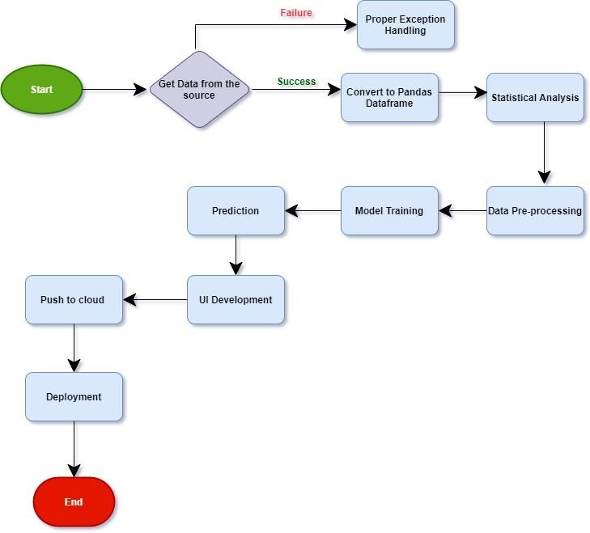

## User I/O workflow



      
      
      
      